**MAJOR PROJECT UPDATE – 27 / 03 / 2020**

COLLEGE WEBSITE (FACULTY MODULE)

Objectives Achieved:

* Public cannot edit but can only view Faculties and Departmental Information.
* Faculties can log in and can only edit specific Information (Experience, Research Details, etc).
* HOD can control whole department (Each Information of any faculty is mutable to HOD.)
* Departments are isolated from one another, HOD of one department cannot change other department information.
* Faculties does not need to logged in into JOOMLA ADMIN ACCOUNT, they can easily edit their data on frontend.

Submitted To:

* Dr. Anuradha Purohit
* Ms. Charushila Choube

Submitted By:

* Aditya Prashant Wagh
* Neelam Bhatiya
* Hemant Sawle
* Dipesh Prajapati
* Bhupendra Singh

1. List of Departments. Clicking on Read More will take to that department.

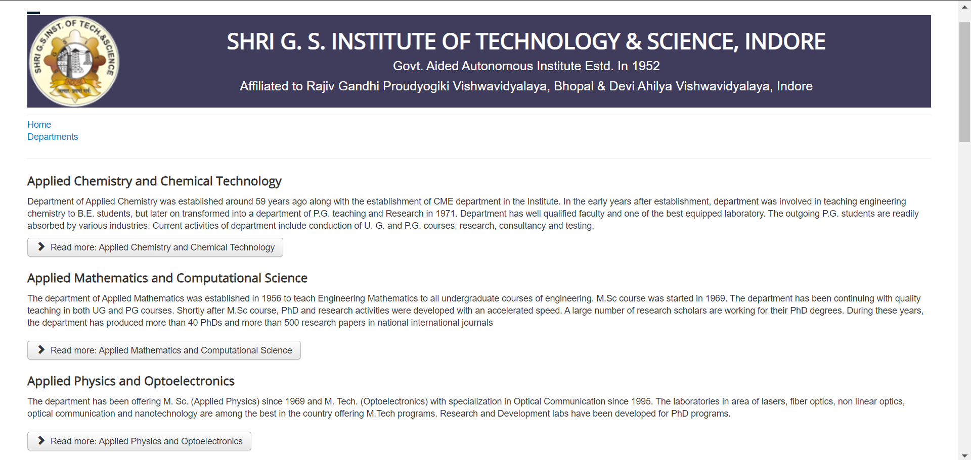

1. Let us click on Applied Chemistry and Chemical Technology

(This is Homepage)

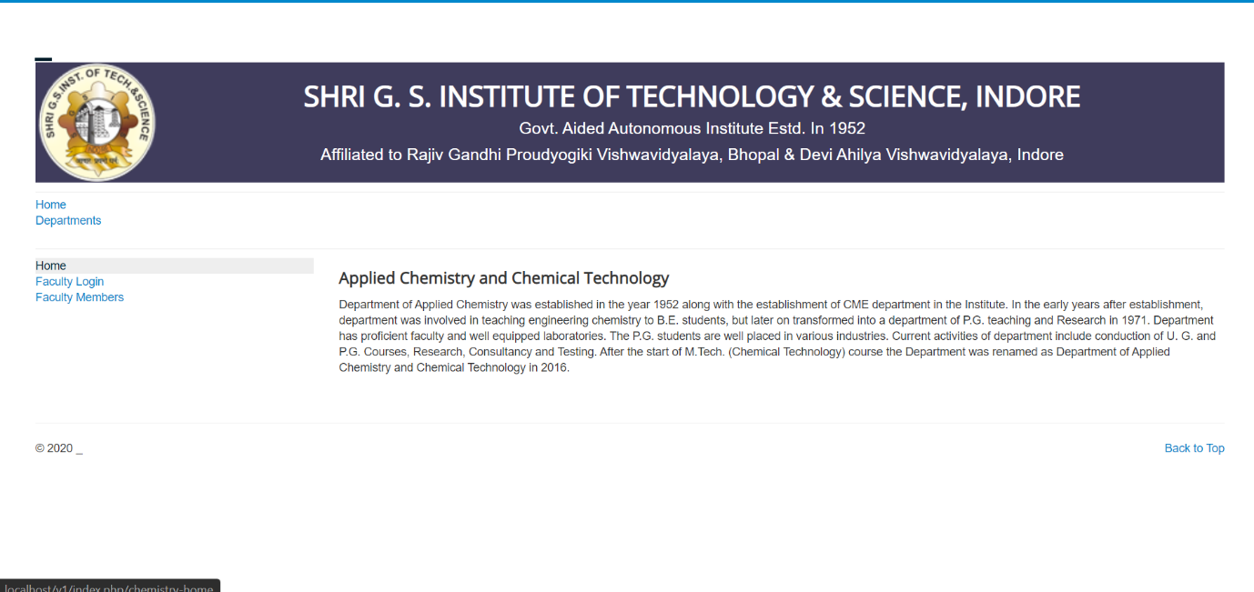

1. Click on Faculty Members Menu

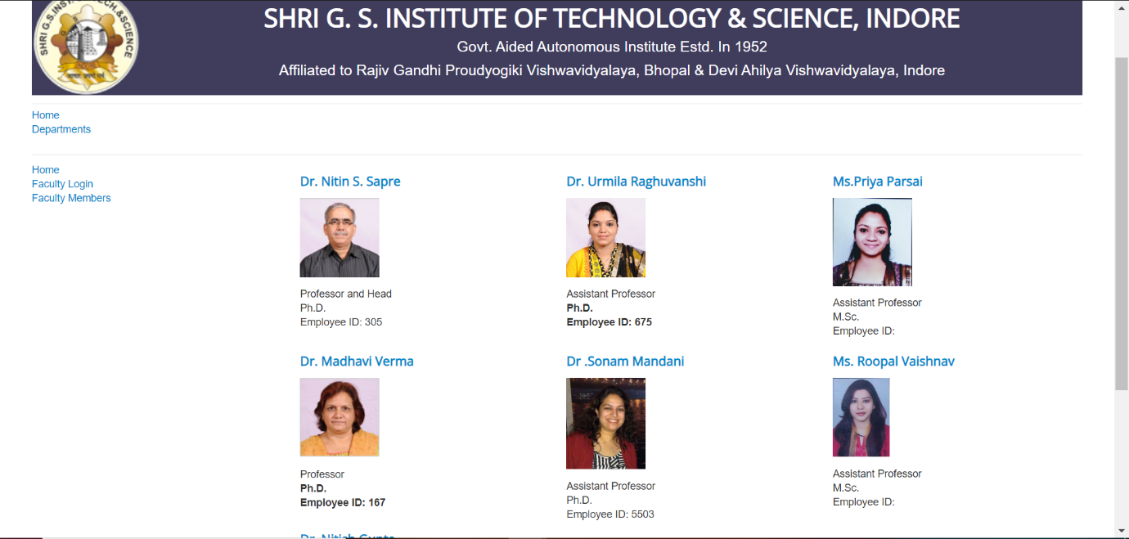

1. Let us go to Dr. Nitin Sapre Sir Profile (No body Logged in)

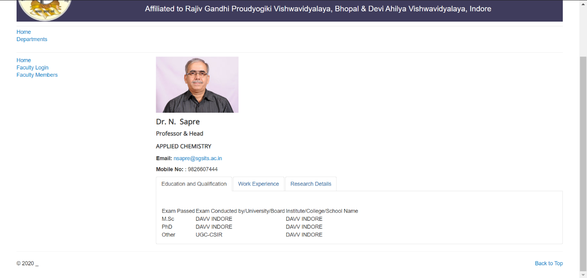

1. Now Suppose Nitin Sapre Sir logged in.

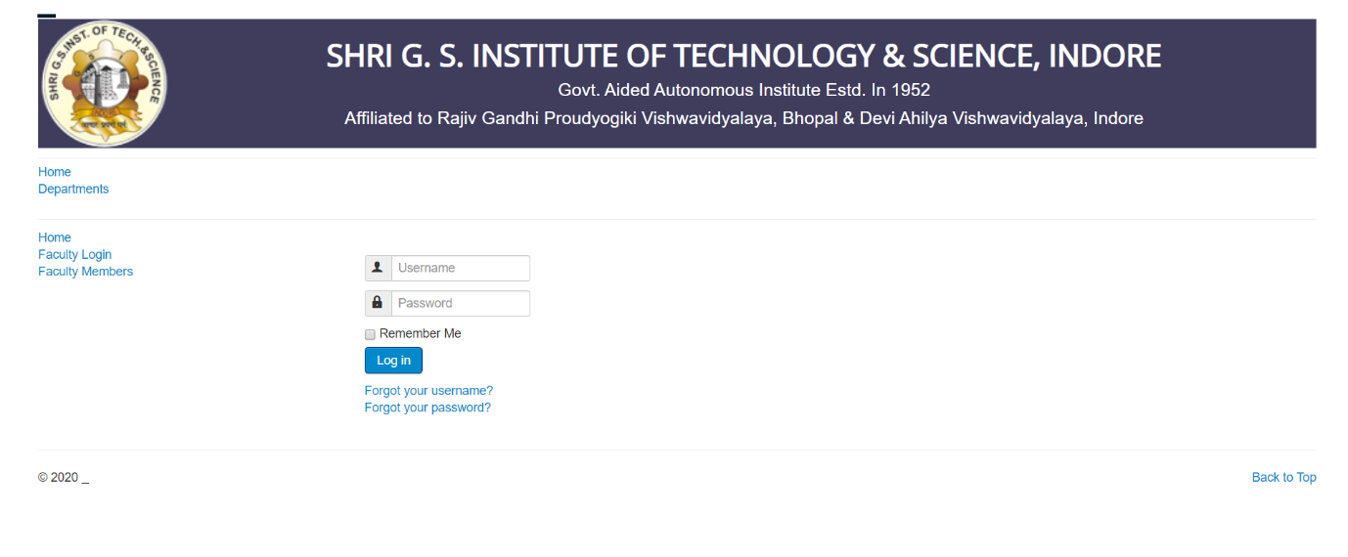

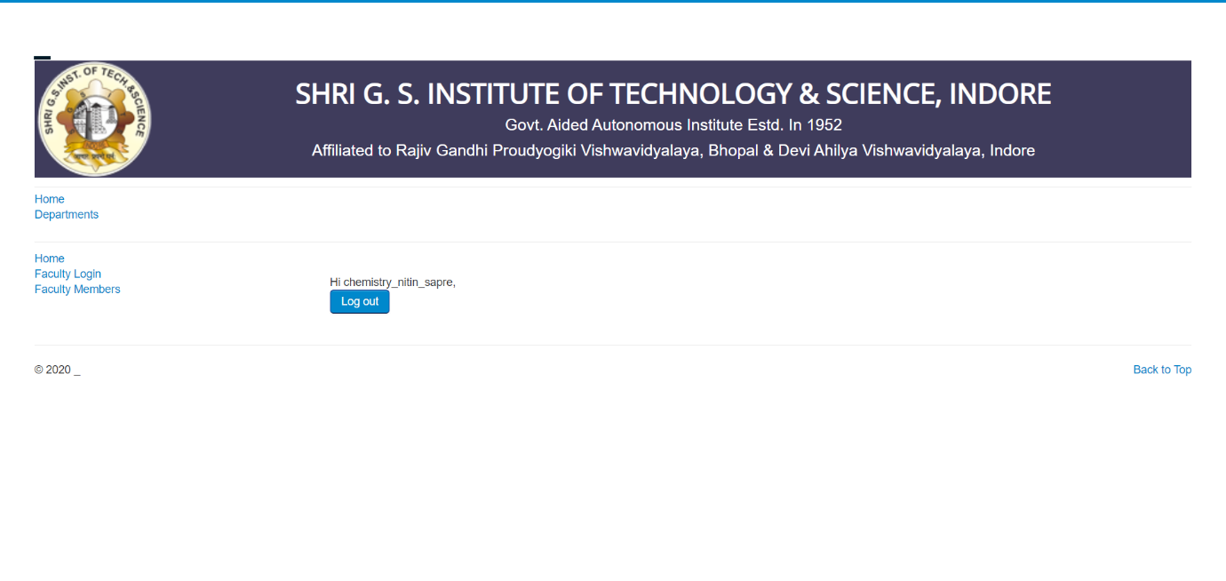

1. Let us now go to Dr. Nitin Sapre Sir Profile (Logged in)

-He should be able to edit some of his details like QUALIFICATIONS, WORK EXPERIENCE, RESEARCH DETAILS.

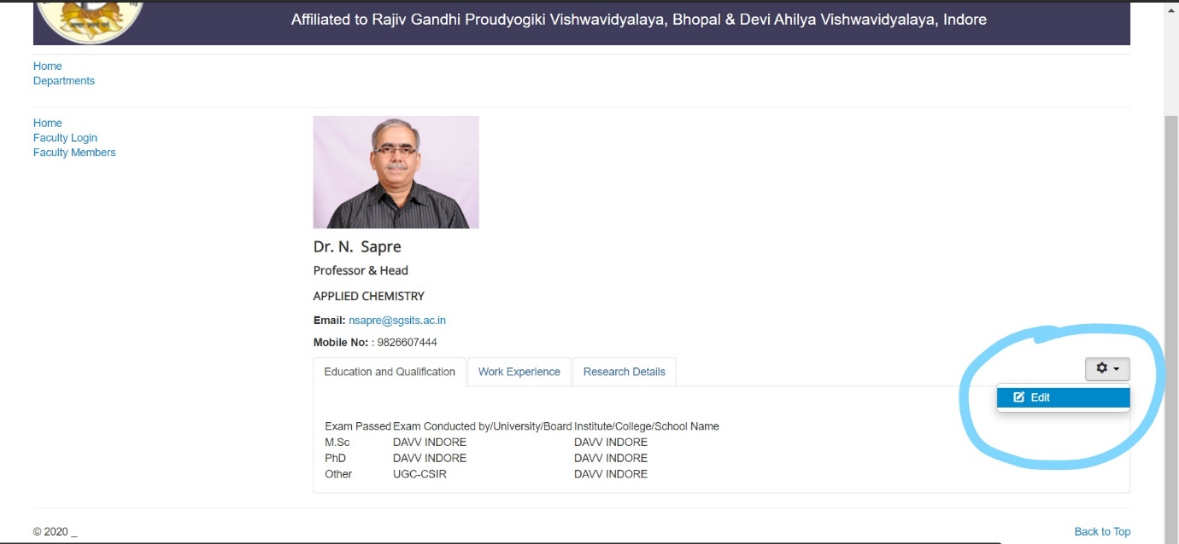

1. Now Suppose CHEMISTRY HOD (ANY) logged in.

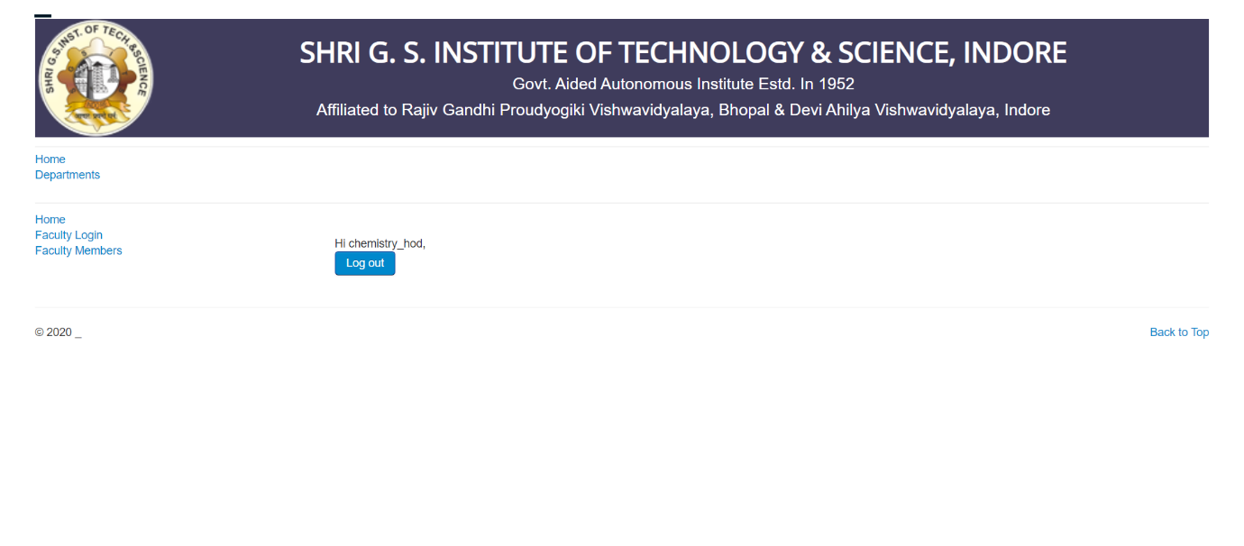

1. HOD should be able to control every information of faculty in their department.

